**PLEASE ANSWER ALL QUESTIONS. Total 25 Marks**

**QUESTION 1 (2+3=5 Marks)**

What are the differences between generic software products and customized products?

“Software costs more to maintain than to develop.” -Explain

**QUESTION 2 (2+2+2=6 Marks)**

What are some of the limitations of the Linear Sequential Model? How does the V-Model address those issues? What is the purpose of daily scrum events?

**QUESTION 3 (2+3=5 Marks)** Consider the following usage scenario for SafeHome:

*SafeHome is a microprocessor-based home security system that would protect against and/or recognize a variety of undesirable "situations" such as illegal entry, fire, flooding, and others. The system will consist of smoke detectors, window and door sensors, motion detectors, an alarm, an event (a sensor has been activated), a control panel, a display, telephone numbers, a telephone call, and so on. The list of services might include setting the alarm, monitoring the sensors, dialling the phone, programming the control panel, reading the display.*

Perform general classification and Object-Oriented Analysis to identify potential classes to develop the system.

**QUESTION 4 (1+1+2+2+1+2=9 Marks)**

A program reads an integer number within the range [1,100] and determines whether it is a prime number or not. Design test cases for this program using BVC, robust testing, and worst-case testing methods.

The code for the program is as below:

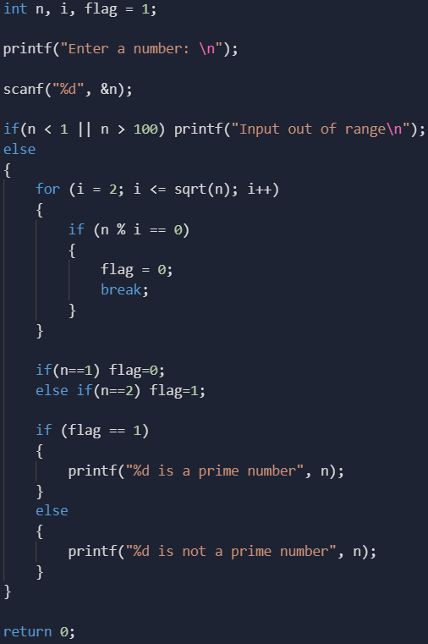

Draw the Control Flow Graph for the program, list all independent paths, calculate the cyclomatic complexity of the program using all three methods.